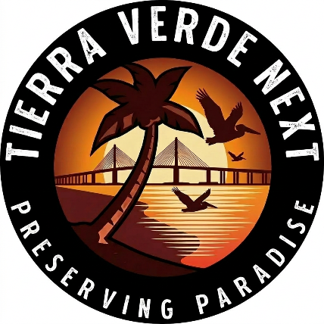
REGULATORY AND LEGAL PROGRESS
Tierra Verde Marina Expansion Project

Legal
June – TV Next files in Circuit Court to overturn St. Petersburg DRC’s site-plan approval. Our filing contends that St. Petersburg did not apply the legally applicable height restriction. This case is still pending.
September – TV Next asks the City of St. Petersburg to rescind the DRC’s approval due to false statements used to secure parking credits. Without the credits, the development fails the city’s basic zoning requirements. The city refuses.
September – St. Petersburg and Greenleaf joined to file motion to dismiss the Court review, saying the residents of Tierra Verde and TV Next do not have standing to contest the DRC decision. TV Next files response noting that we were uncontested registered opponents in the DRC case.

Regulatory
As of today, not one state or federal agency has found this project satisfies requirements.

Florida Fish and Wildlife Conservation Commission (FWC) — July – FWC letter states that it cannot favorably recommend any proposed increase in slips, including dry slips. To date, Greenleaf has not addressed this issue.
Southwest Florida Water Management District (SWFWMD) — July – Issues second request for additional information regarding stormwater drainage (pervious versus impervious areas) and requests an answer to the FWC issue. September – Issues follow-up questions regarding the same issues. SWFWMD may require a new permit or an upgrade of the existing application to a “major modification.” If a new permit, the project must meet requirements for stormwater treatment adjacent to Outstanding Florida Waters. Greenleaf has until Oct. 8 to reply with satisfactory answers or SWFWMD has the right to cancel the application. Application still incomplete after 14 months.
Florida Department of Environmental Protection (FDEP) — August – Issues a formal warning letter after an inspection requested by TV Next finds Tierra Verde Marina is in violation of obligations in its state submerged lands lease. Among these is a requirement that 90 percent of wet slips—80 of 89 slips—be available to the general public on a first-come, first-served basis. Issues regarding submerged land lease are ongoing.
If SWFWMD forces Greenleaf to resubmit the application as a major modification, the U.S. Army Corps of Engineers will be responsible for processing the application. Other federal agencies could also become involved.

